Assignment 4
Topic： System Design Date： Class：
Name： StudentID： Score：

- Ticket Sales System has the following class diagram as below, please split them into several packages according to system design principles.
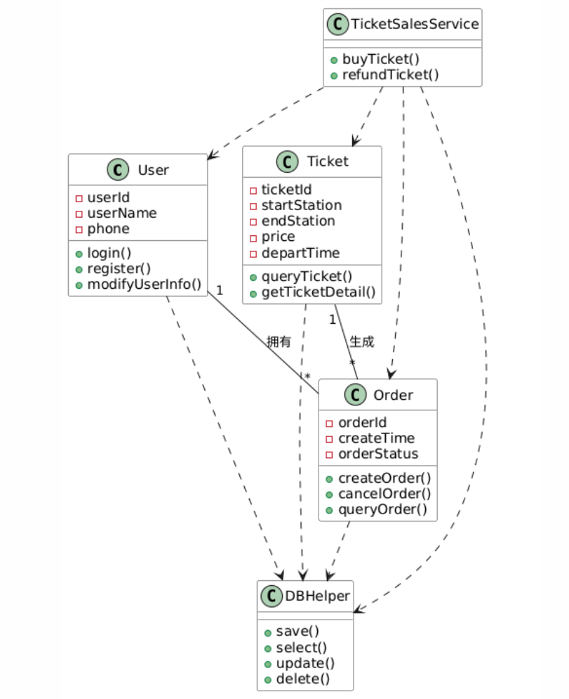
- A student management system adopts an unstandardized layered structure. The UI layer directly operates the database without business layer isolation. The core servlet code is as follows:
public class StudentServlet {
// UI layer directly accesses database
public void queryStudent() {
MySQLDatabase db = new MySQLDatabase();
db.connect();
// Execute SQL and return data directly
}
}
Requirements:
- Analyze the defects of missing layered architecture and the risks of cross-layer calling.
- Draw the standard three-layer architecture diagram (UI / Business Logic / Data Access Layer) and clarify the responsibilities of each layer.
- Refactor the code to realize layer isolation and low coupling.
- Explain the advantages of standardized layered architecture in system maintenance and expansion.

